Sentiment Analysis Using Machine Learning Models

1. Project Overview
This project focuses on building a multi-class sentiment analysis system using traditional Machine Learning (ML) algorithms. The goal is to classify social media text into various sentiment categories such as Positive, Joy, Excitement, Neutral, Sad, Gratitude, and many more.
The project covers the complete ML pipeline:
- Data loading and inspection
- Exploratory Data Analysis (EDA)
- Text cleaning and preprocessing
- Feature extraction using TF-IDF
- Model training and comparison
- Evaluation and model selection
- Model saving and prediction on new text
The workflow and results are based on the notebook/report provided in the project file
Sentiment Analysis Using ML Mod…
.

2. Objectives
- Perform sentiment classification on textual social media data
- Compare multiple ML models for performance
- Identify the best-performing model
- Build a reusable pipeline for predicting sentiment on new text

3. Dataset Description
The dataset contains 732 social media records with the following features:
- Text – Main content for sentiment analysis
- Sentiment – Target label (multi-class)
- Timestamp, Year, Month, Day, Hour – Time features
- User, Platform, Country – Contextual metadata
- Hashtags, Likes, Retweets – Engagement metrics
Key observations:
- No missing values in the dataset
- Highly imbalanced sentiment classes
- 279 unique sentiment labels initially

4. Exploratory Data Analysis (EDA)
EDA was conducted to understand sentiment patterns:

✔ Sentiment Distribution
- Top 10 sentiments were selected for clearer analysis
- Large class imbalance observed
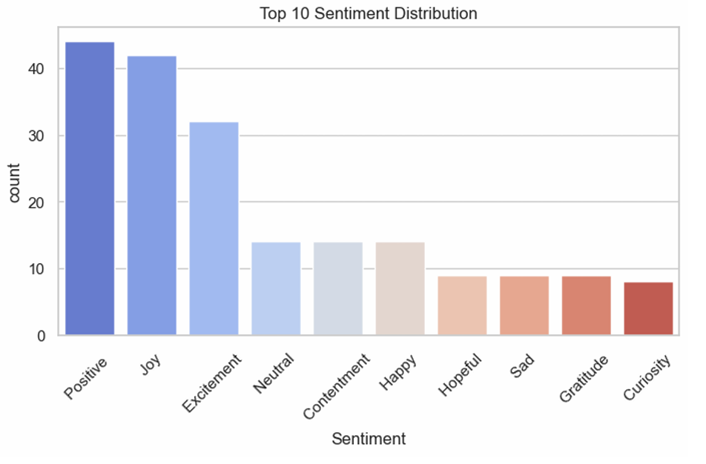

✔ Platform-wise Analysis
- Sentiments vary across Twitter, Instagram, and Facebook
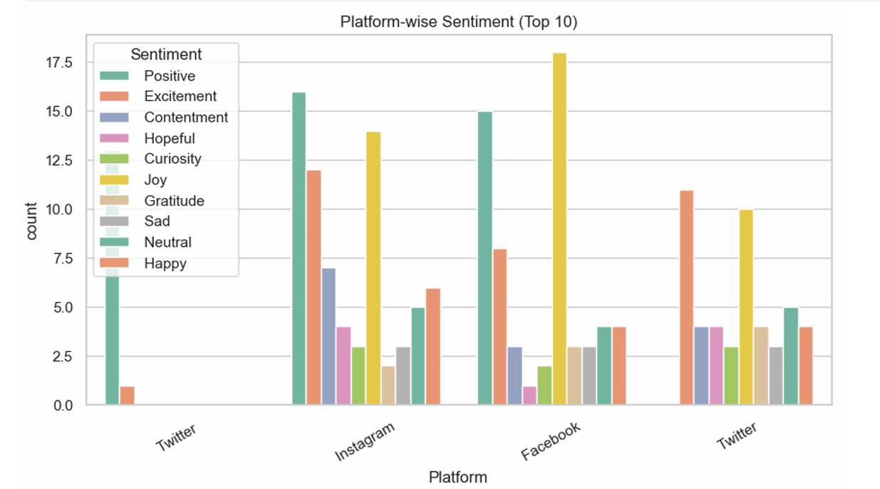

✔ Country-wise Analysis
- Different countries show different sentiment trends
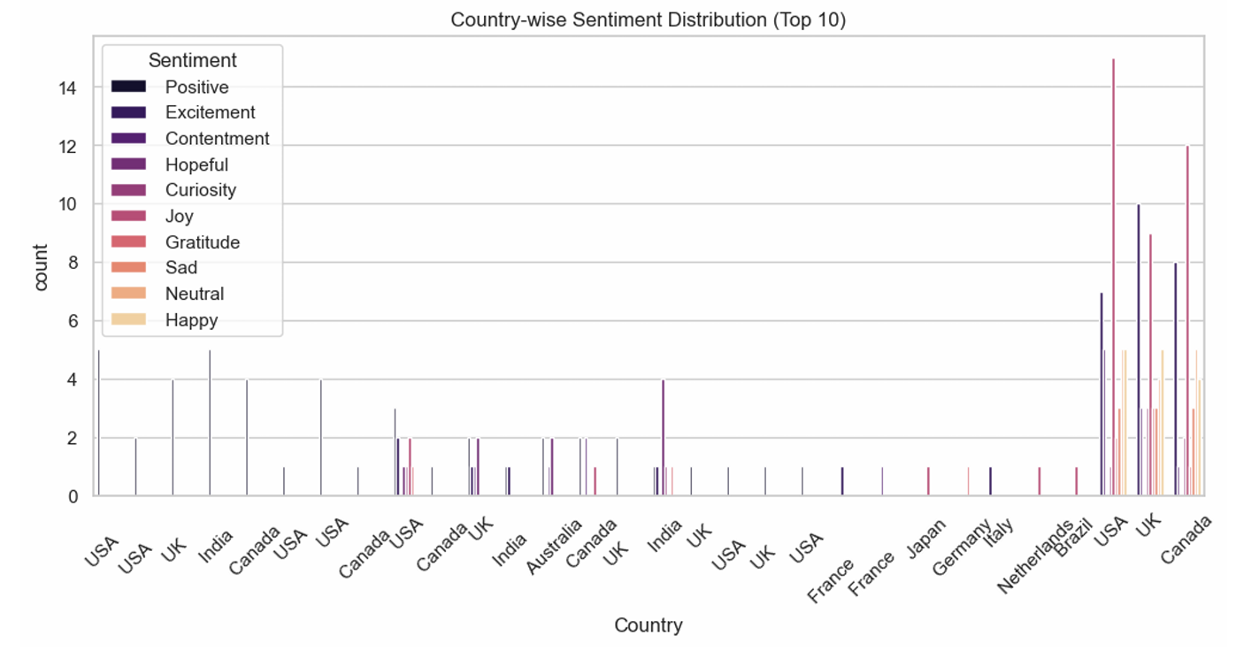

✔ Engagement Analysis
- Scatter plots of Likes vs Retweets revealed engagement patterns per sentiment
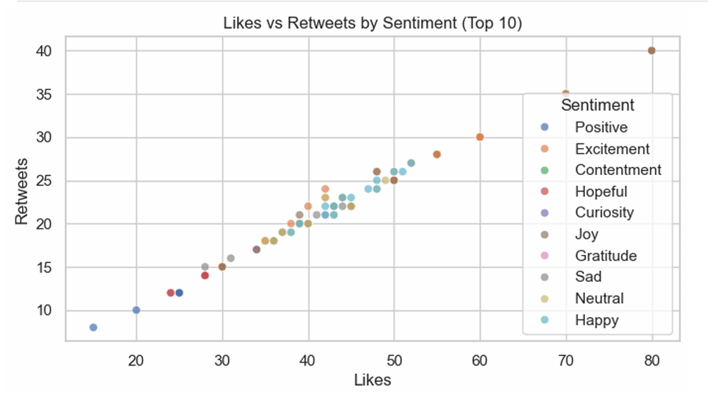

✔ Time-based Analysis
- Sentiment activity analyzed by hour
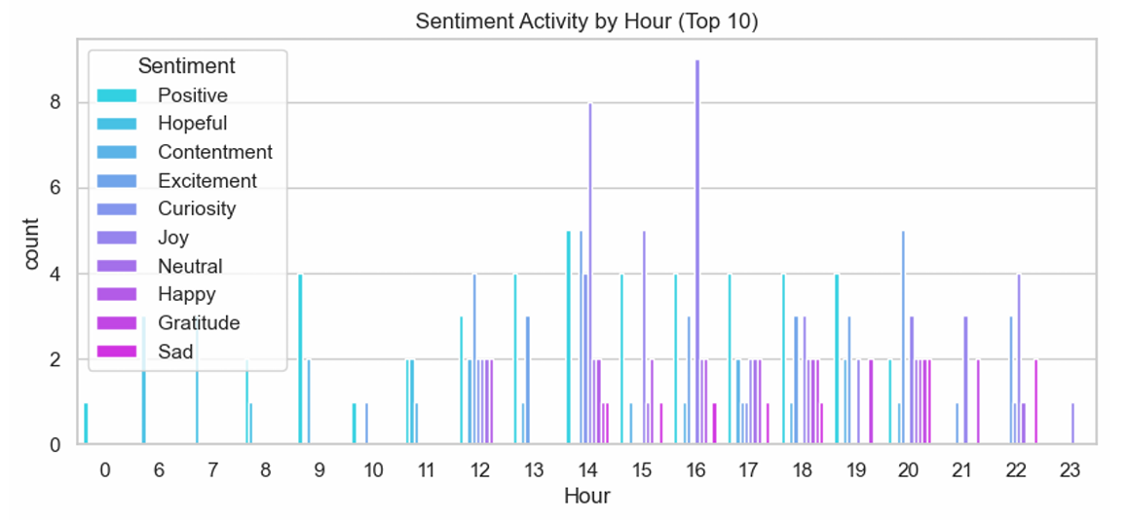

5. Text Preprocessing
Text cleaning steps included:
- Lowercasing text
- Removing URLs, mentions, and hashtags
- Removing punctuation and special characters
- Stopword removal using NLTK
- Creating a cleaned text column
Example:
"Enjoying a beautiful day at the park!"
→ "enjoying beautiful day park"

6. Text Analysis
Additional analysis included:
- Word count distribution per sentiment
- Most common words per sentiment
- WordCloud visualization for top sentiments
This helped identify dominant words linked to specific emotions.
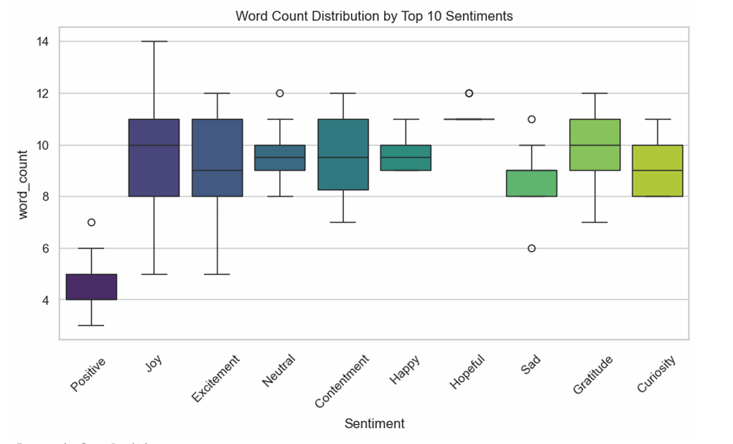

7. Feature Engineering

TF-IDF Vectorization
Configured with:
- max_features = 15000
- ngram_range = (1,3)
- min_df = 2
- max_df = 0.95
Rare sentiment classes (<2 samples) were grouped into "Other" to reduce noise.

8. Model Training
The following models were trained:
- Logistic Regression
- Naive Bayes
- Linear SVM
- Random Forest
Data split:
- 80% Training
- 20% Testing
- Stratified sampling used

9. Model Performance
Model | Accuracy
Logistic Regression | 21.77%
Naive Bayes | 19.73%
Random Forest | 43.54%
Linear SVM | 46.26% (Best)

✅ Best Model: Linear SVM
Chosen due to highest accuracy.
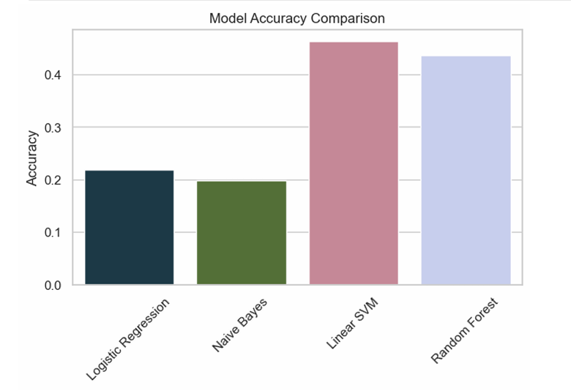

10. Evaluation
A detailed classification report showed:
- Strong performance on some classes
- Weak performance on rare classes
- Impact of class imbalance visible
Weighted accuracy: ~46%

11. Sample Predictions
Text | Predicted Sentiment
I love this new feature! | Love
The service was awful and slow. | Disappointed
It's okay, not too bad but not great either. | Bad

12. Tech Stack
- Python
- Pandas, NumPy
- Matplotlib, Seaborn
- NLTK
- Scikit-learn
- WordCloud
- Joblib

13. Conclusion
This project successfully developed a multi-class sentiment analysis system using machine learning on social media text data. The end-to-end pipeline included data exploration, text preprocessing, TF-IDF feature extraction, and training multiple classification models.
The results showed that Linear SVM performed best, achieving the highest accuracy among the tested models. The experiment also revealed important practical insights: real-world sentiment datasets are often highly imbalanced, and having many fine-grained sentiment labels makes classification more difficult. These factors directly influenced model performance.
Despite moderate accuracy, the project effectively demonstrates core NLP and machine learning competencies such as text cleaning, feature engineering, model comparison, and evaluation. It highlights how traditional ML approaches can serve as strong baselines for text classification tasks.
Overall, this project provides a solid foundation for further improvement. With larger datasets, better class balancing, and advanced models like transformer-based NLP (e.g., BERT), performance can be significantly enhanced. This work showcases practical skills in data analysis and NLP that are valuable for real-world applications.

